Name: Abhinay P
Domain: Data analyst
Project: Twitter Analytics Dashboard-Power BI
Task 4: Create a line chart showing the trend of average engagement rate over each month of the year. Separate the lines for tweets with media content and those without and this graph should work only between 3PM IST to 5PM IST and 7AM IST to 11 AM IST apart from that time we should not show this graph in dashboard itself and the tweet engagement should be even number and tweet date should be odd number as well as tweet character count should be above 20 and need to remove tweet word which has letter ‘c’.
Data preparation and validation:
To meet the task requirements, several calculated columns were created to support filtering and classification. These calculations enabled the identification of valid tweets based on engagement parity, posting date parity, time-of-day constraints, media presence, and cleaned tweet content.
Special attention was given to text preprocessing, where only words containing the letter ‘C’ were removed, rather than excluding entire tweets. The cleaned tweet text was then used to calculate character count, ensuring accurate compliance with the condition requiring tweet length greater than 20 characters.
Conditions applied:
The visualization contains conditions such as:
- Tweet engagement value is an even number
- Tweet was posted on an odd-numbered calendar date
- Tweet character count should be greater than 20 after cleaning
- Tweet text has had only words containing the letter ’c’ removed
- Tweet was posted within either of the valid time windows: 7 AM IST to !!AM IST and 3 PM IST to 5 PM IST
- Tweets should be classified into with media and without media based on media presence
Visualization design:
A line chart was selected (given in the task) as it is the most suitable visual for analyzing trends over time.
The chart is structed as:
X-axis: Tweet year-month (continuous date)
Y-axis: Average engagement rate
Legend: media type
Result and observations:
After applying all the conditions and correcting the x-axis configuration, the line chart accurately displays the monthly average engagement rate trend for qualifying tweets. Separate lines for tweets with media and without media allow for clean comparison of engagement behavior across months. Variations in the trend indicate how engagement fluctuates over time and how media presence influences audience interaction. Any missing months or gaps in the lines reflect periods where no tweets satisfied all conditions simultaneously, confirming correct filter implementation rather than data or modeling errors. The image of the chart is shown below:
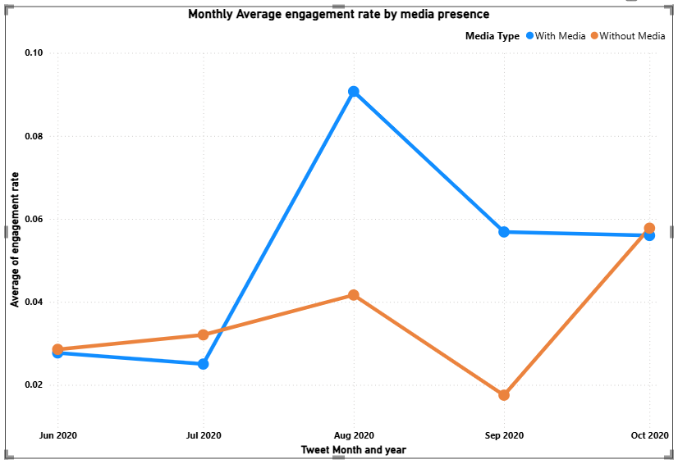
Key insights:
- Engagement trends vary month to month, highlighting the importance of temporal analysis.
- Tweets containing media generally show different engagement behavior compared to non-media tweets.
- Strict filtering significantly reduces the dataset, reinforcing the importance of validating data availability before drawing conclusions.
- Correct chronological ordering of the x-axis is critical for accurate trend interpretation.
Conclusion:
This task demonstrates effective use of Power BI calculated columns, time intelligence, text preprocessing, and visual-level filtering to deliver a controlled and accurate trend analysis. By correcting axis configuration issues and strictly enforcing all business conditions, the final visualization provides a reliable comparison of engagement trends by media presence. The outcome emphasizes both analytical rigor and the importance of proper visual configuration in data storytelling.

